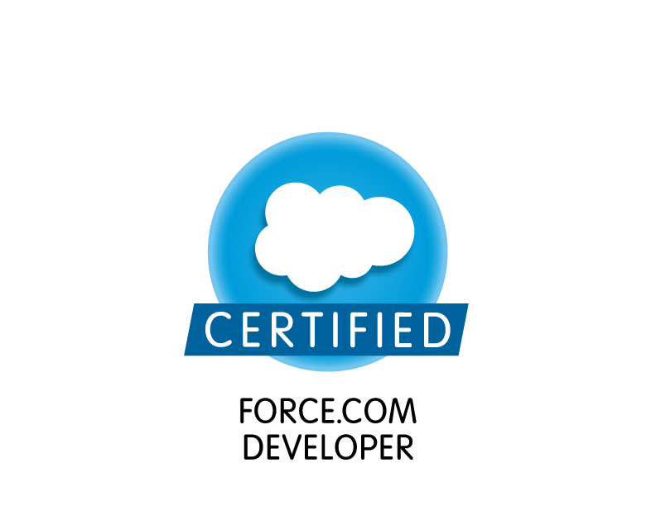
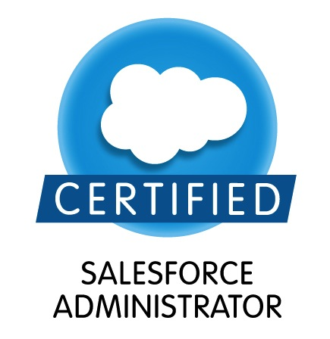
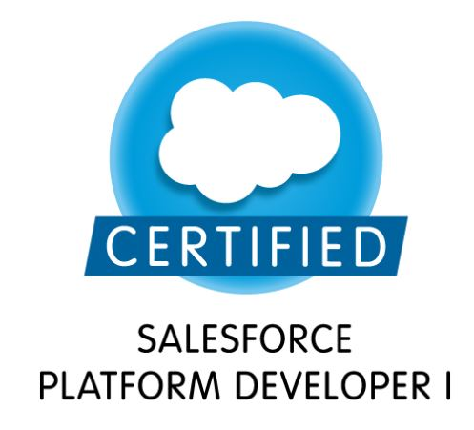
M Senthil Kumar
Mob: 8892442846
Email: m.senthil97@gmail.com

PROFESSIONAL SUMMARY

- Around 4+ years of experience on analysis, coding, testing, implementation and Enhancement of Salesforce and worked on Agile methodology.
- Designed Custom formula fields, Field dependencies, Validation rules, workflows, approval process, process builder and flows.
- Good exposure to Standard Objects functionality like Leads, Accounts, Contacts, Opportunity, Contract, Quote, Product, Pricebook, Cases.
- Implemented security and sharing rules at object, field and record level for different users at different levels of organization.
- Working knowledge on development work including triggers, apex, visual force pages.
- Having knowledge on Heroku Integration.
- Having Experience on Apttus CPQ Configuration, Apttus CLM.
- Ability to quickly learn new technologies, tools and work on them.
- Having good communicational, interpersonal, Analytical and problem solving skills.
- Ability to work independently and in a team.
- Good Understanding of Cloud computing – SALES FORCE and its concepts to implement business solutions for CRM applications and mapping them to product features.

ACADEMIC PROFILE

Education | Name of the Institution | University/ Board | Duration | % of Marks
BE(CSE) | Government College of Engineering | Anna University- tirunelveli | 2007-2011 | 70.83
Intermediate  (+2) | Masood Thaika Higher Secondary School | State Board | 2006-2007 | 91.33
SSC | Masood Thaika Higher Secondary School | State Board | 2004-2005 | 91.40

Certifications
- Certified salesforce.com developer (Dev 401).
- Certified salesforce Platform developer 1
- Salesforce Certified Administrator (Admin 201).
- Programming in HTML5 with Javascript and CSS3.

TECHNICAL SKILLS

Programming Skills | C, Java, Apex, Visual force.
Operating Systems | Windows 2000/XP, 7
Web Technologies | HTML, DHTML, JQuery, AJAX, SQL, SOQL
Database | Oracle 10g
Packages | MS Office
Server | Apache, Xamp
Quality Tools | HP Quality Center, fire bug.

WORK EXPERIENCE
- Working for BirlaSoft India Ltd, Bangalore from December 2012 till date.

PROJECT DETAILS
Project Name: Disney Apttus CLM (Jun 2016 – till Date )
Application Name | Disney Studio, Network, Cable
Client | Disney
Role | Software Engineer
Team Size | 22
Environment | Salesforce.com
Tools | Dataloader, Force.com IDE, Workbench, Eclipse.

Project Description:

The Disney/ABC Television Group is composed of The Walt Disney Company’s global entertainment and news television properties, owned television stations group, as well as radio and publishing businesses. This includes the ABC Television Network, ABC Owned Television Stations Group, ABC Entertainment Group, Disney Channels Worldwide, ABC Family as well as Disney/ABC Domestic Television and Disney Media Distribution. Our project ABC Studio/Network/Cable provided the solution to manage the deals in salesforce platform and eliminated the manual work.

Responsibilities:

- Worked on Configurations using Objects, Tabs, Fields, Relationship types and Record types.
- Designed Custom formula fields, Field dependencies, Validation rules, workflows, approval process.
- Implemented security and sharing rules at object, field and record level for different users at different levels of organization.
- Worked on standard objects like Accounts, Contacts and Custom objects.
- Worked on reports and dashboards.
- Worked on Apex Classes, Apex Triggers, Lightning Component Bundle, Visualforce pages and Email Templates.
- Created Lightning Application using Lightning component, SLDS.
- Worked on Salesforce Lightning Design System (SLDS), Lightning App builder.
- Used the sandbox for testing and migrated the changes using change sets between sandboxes and production for final implementation.
- Worked on Conga Composer to generate the documents.
- Provided support for the users on Production

Project Name: GEHealthcare Apttus.
Application Name | GEHealthcare
Client | GE Healthcare (US).
Role | Software Engineer
Team Size | 10
Environment | Salesforce.com
Tools | Dataloader, Force.com IDE, Workbench, Eclipse.

Project Description:

GE Healthcare provides transformational medical technologies and services helping to deliver patient care to people around the world. The company provides medical imaging and information technologies, medical diagnostics, patient monitoring systems, drug discovery, biopharmaceutical manufacturing technologies and performance solutions services. GEHC Global Application is built in Salesforce to manage the sales part of GE Health Care and being used by 30000 users. This application is used by the Asia and Non Asia Regions to manage Sales Processes. We are currently working on CPQ Enhancements and migration of new regions in to GEHC Global Application.

Responsibilities:

- Worked on Configurations using Objects, Tabs, Fields, Relationship types and Record types.
- Designed Custom formula fields, Field dependencies, Validation rules, workflows, approval process.
- Implemented security and sharing rules at object, field and record level for different users at different levels of organization.
- Created chatter groups and configured.
- Worked on standard objects like Leads, Accounts, Contacts, Opportunities, Quote, Contract, Products, Price book, Lead process, Sales process, Cases.
- Worked on reports and dashboards.
- Worked on Apex classes, Apex triggers and Visualforce pages.
- Worked on data remediation using dataloader and workbench.
- Used the sandbox for testing and migrated the changes using change sets between sandboxes and production for final implementation.

Project Name: GE Aviation Service Cloud
Application Name | GE Aviation Service Cloud-GEASC
Client | GE Aviation.
Role | Associate Software Engineer
Team Size | 6
Environment | Salesforce.com
Tools/Packages | Dataloader, Force.com IDE, Workbench, Eclipse.

Project Description:

GEASC is a Service cloud Application of GEAviation it involves dealing of customer cases and its resolutions. The case will go to different levels Approval process.

Responsibilities:

- Created Record types and page layout for cases.
- Loading data using Apex Data Loader and backup using eclipse.
- Created Validation rules, Workflows and approval process.
- Implemented Email Notification Template for Each Approval Process.
- Developed Reports and Dashboards for various Business needs.
- Worked on Apex Triggers and Visualforce.

Project Name: GE Health Care
Application Name | MyWorkshop
Client | GE Health Care
Role | Associate Software Engineer
Team Size | 6
Environment | MyWorkShop, Oracle SQL Developer, Oracle ERP, Mainframe.
Tools | HP Quality Center 10.0

Project Description
The MyWorkshop system, represents the merger, enhancement, and upgrade of two existing systems. The original systems were ePDM (Engineering Central and Technical Publications), implemented in March 2003, and eLibrary (Document Central and Research Agreement), implemented in December 2002. The primary purpose of the merge was to consolidate infrastructure, utilize common features among the applications and capitalize on process integration opportunities. The system provides features, processes and workflows, such as approval processes, for the data types and associated files
Roles & Responsibilities
- Understanding the application thoroughly with help of Customer Requirement Specification document.
- Involved in test case design and preparation and execution of Manual Test’s Scenario.
- Involved in Stand Up meetings, responsible for tracking the issues
- Involved in verification of data flow to the Downstream systems.
- Involved in Smoke, Integration, E2E , Downstream, Data Migration and System Testing.
- Actively involved in logging defects using Defect tracking tools.
- Active participation in Defect Report Meeting periodically.
- Validation of Test’s Scripts Using HP Quality Center 10.0.
- Mapped the Requirements in Requirement Traceabality Matrix.

Environment: MyWorkShop, Oracle SQL Developer, Oracle ERP, Mainframe.

